**Heuristics Approach of Multiple Containers Loading Cost Minimization Problem**

**Main idea:**

* Choose the best appropriate container to put items in:

+ Best value (Cost/Area)

+ Largest or Smallest

+ Cheapest

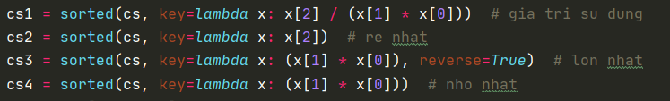

* Sort the items list in order of size (Area): Ascending or Descending
* 
* Loading order:

+ Pick the best item from sorted list of items, then put it at the left-most bottom corner of the picked container.

+ Find the next left-most bottom corner (bottom priority), check if there are still item to put in the containers then continue the process.

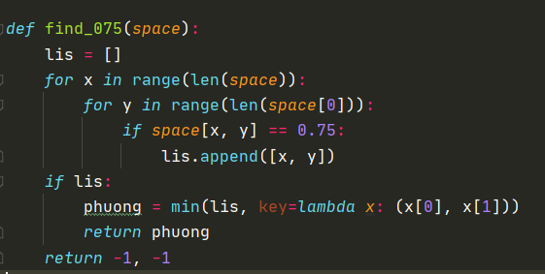

+ If there are no item left that is possible to put in: move to the next container.

* There are 2x4 = 8 ways to choose containers and sort item list in total. To guarantee the best solution of heuristics, we decided to go through all 8 cases and take the minimum cost case.

4

33

2

1